A STEP BY STEP GUIDE FOR STUDENTS TO ACCESS GOOGLE CLASSROOM

STEP 1: Sign into Google via the [G Suite Hub](https://accounts.google.com/ServiceLogin/identifier?passive=1209600&continue=https%3A%2F%2Fgsuite.google.com%2Fdashboard&followup=https%3A%2F%2Fgsuite.google.com%2Fdashboard&flowName=GlifWebSignIn&flowEntry=AddSession) and enter your username, sID#@gse.cusd80.com, and password "sID#!"

* *For example, if your students ID is 123456, your username is*[*s123456@gse.cusd80.com*](mailto:s123456@gse.cusd80.com)*and your password is s123456! (case sensitive).*
* *You will not be prompted to change your password, but it is recommended you do so. Be sure to make note of your password in the event you forget it in the future.*

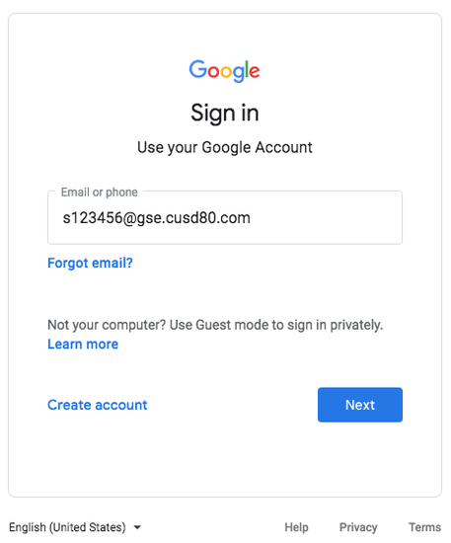

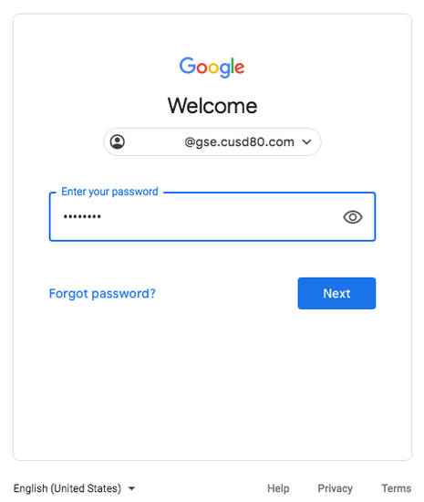

STEP 2: Click the "waffle" icon in the top right of your screen, near your initial or photo icon.

Scroll until you find the Google Classroom app. If the Google Classroom icon isn't there, please visit classroom.google.com.

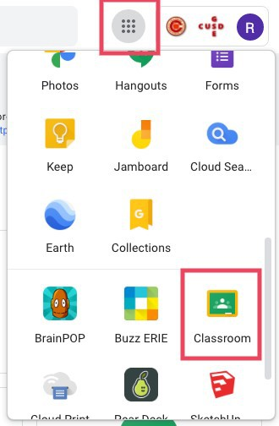

STEP 3: After launching the Google Classroom app, you will see all your classes listed. Please know you may not see all of your classes until Wednesday, August 5.

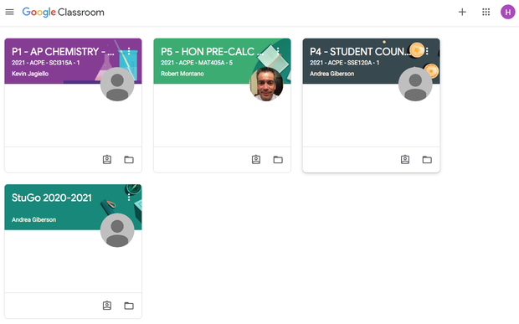

Click on the class that you wish to visit. The class will launch and you will see general information. You might also see a link in order for you to participate in an upcoming Google Meet. You can also review messages or discussions left on the stream, view your classwork and see the people enrolled in your class. Your teachers will assist you with using Google Classroom at the start of the year and throughout virtual instruction.

|  |  |  |
| --- | --- | --- |
| [[Gallery image](https://s.smore.com/u/b9d2dab9242d9ee2e72db55bd7d13fb3.jpg)](https://s.smore.com/u/b9d2dab9242d9ee2e72db55bd7d13fb3.jpg) | [[Gallery image](https://s.smore.com/u/1e6b6815e4a1d4626b4b31e1678c0ffb.png)](https://s.smore.com/u/1e6b6815e4a1d4626b4b31e1678c0ffb.png) | [[Gallery image](https://s.smore.com/u/e288552a4f0c3740e0a24ea85037c725.png)](https://s.smore.com/u/e288552a4f0c3740e0a24ea85037c725.png) |